A general aviation submission provides the following defect report. "Corrosion was found on the forward and aft wing spars under the fuel tank spacer blocks (P/N 0523524) in the fuel tank mounting bay. This problem was discovered when the fuel tanks were removed for repair. No visual corrosion indications were noted around the spacers when mounted. These spacers were removed on a 'hunch' that underlying corrosion might exist. This condition *(was found)* in both wings."

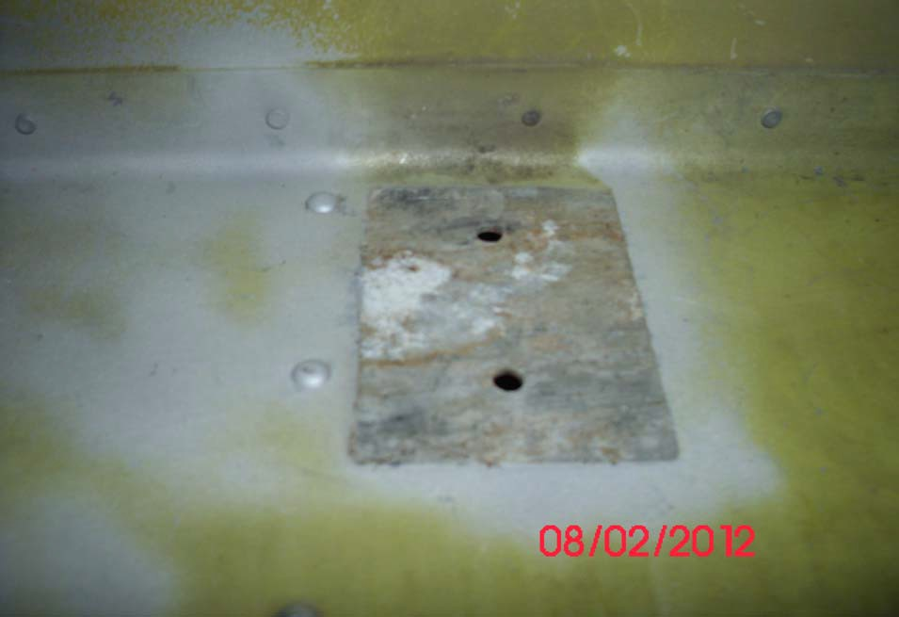

























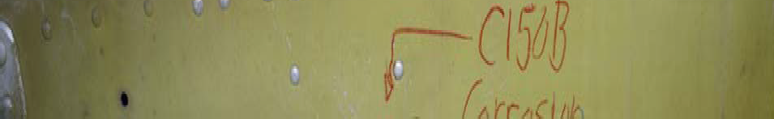



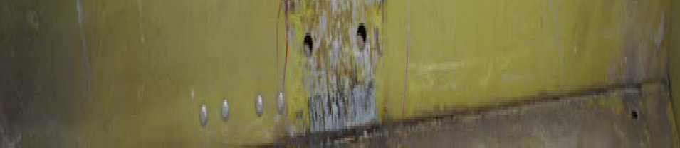



























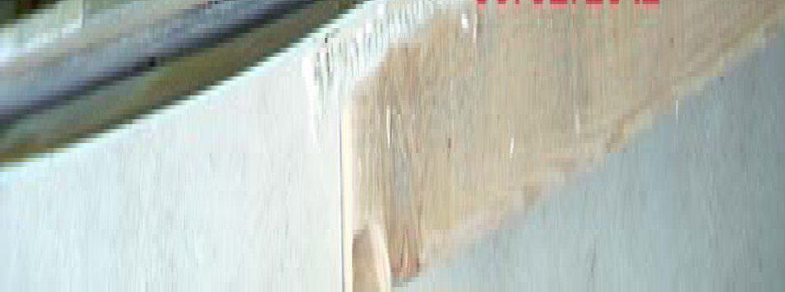

Part Total Time 7,400 Hours